**GitHub**

Git is open-source version control software, used for managing and tracking file revisions.

GitHub is an online software development platform used for storing, tracking, and collaborating on software projects.

It enables developers to upload their own code files and to collaborate with fellow developers on open-source projects.

**What is GitHub used for?**

* GitHub allows software developers and engineers to create remote, public-facing repositories on the cloud for free. Once you’ve set up a repository on GitHub, you can copy it to your device, add and modify files locally, then “push” your changes back to the repository where your changes are displayed to the public.
* Handles small to very large projects efficiently.
* Maintains historical & current versions of source code.

**How to create account in Github?**

* Create Account on Github.com
* Click on this Link <https://github.com/>
* Sign up with your credential (Email, Password)

**How to create repository?**

* Once your GitHub account is set up, you’ll be taken to your dashboard.
* Create repository by clicking on Create repository button on top left in green colour or top right with + symbol.

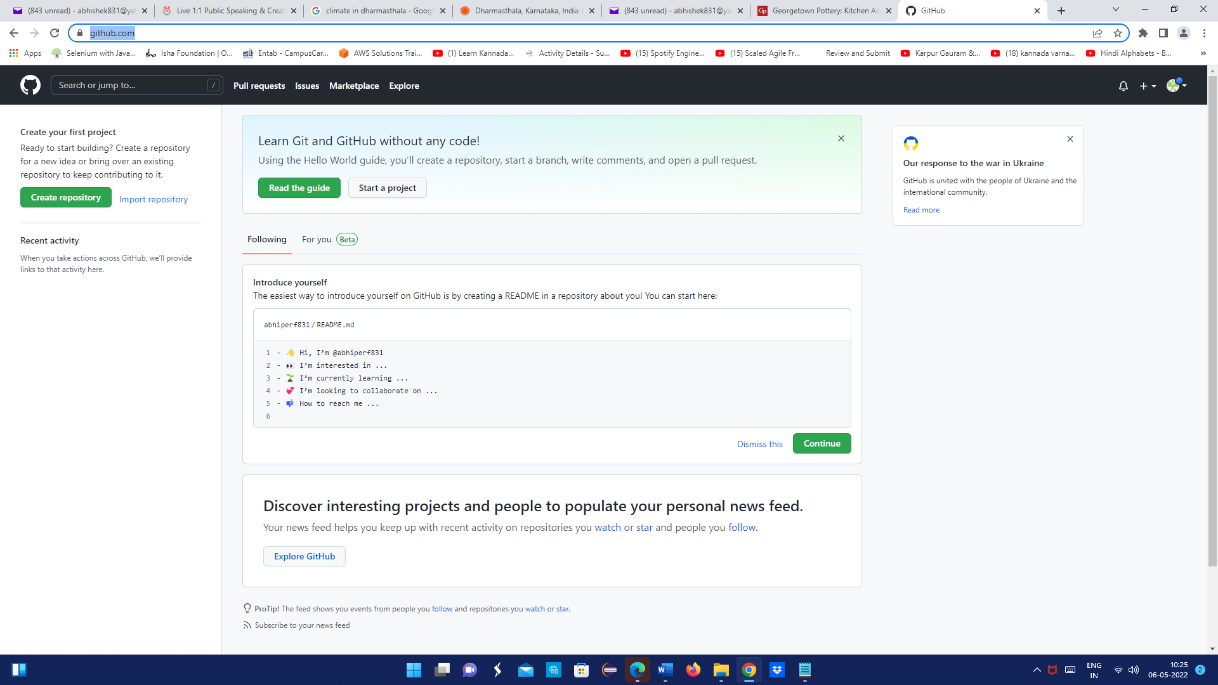

* 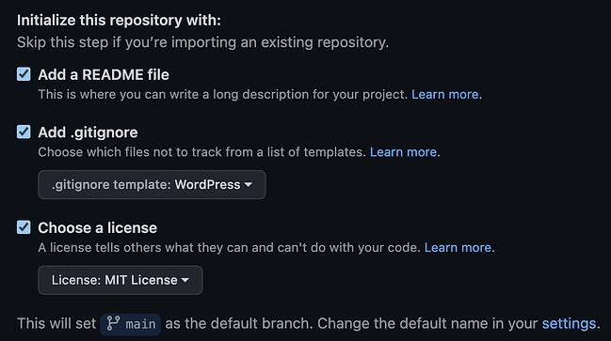Create new repo by giving some meaningful name, select public and On the same screen, add a README file (a text file that describes your project, and a best practice in development). 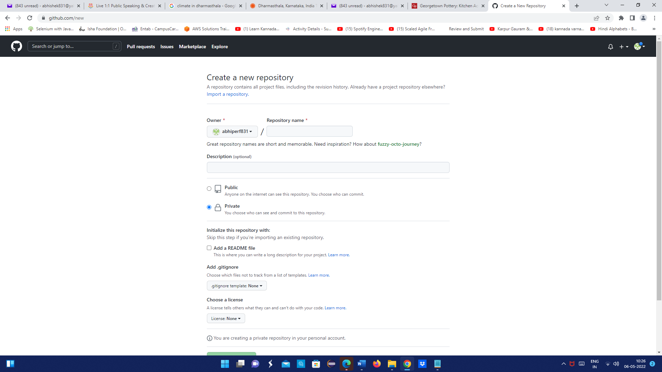
* Then click on “create repository” which is in green colour button. You’ll be taken to your main repository page, which lists your files.

**How to Download git?**

* Cntrl+click to follow link: [git download](https://git-scm.com/downloads)
* Click on windows
* Select 32 or 64 bit git for windows set up as per your system requirements.
* Then the download will start automatically
* **How to Set the environment variables?**
* Type “edit the system environment variables” in start menu
* Bottom right click on “Environment variables button”
* In system variables box, find “path”
* Click on path & click on edit button
* Now click on “New” button
* Go to file explorer, cdrive<programfiles<Git<cmd [copy and paste this “C:\Program Files\Git\cmd” in new]
* Then click on Ok, Ok...
* Check if git is installed properly or not by giving “git --version” command in command prompt.

**Git Commands**

* Go to file explorer, select your desired project/folder, then right click on folder/file & select “git bash here”.
* Use below commands to push a project to github

1. git init

2. git status

3. git add .

4. git commit –m “first commit”

5. git status

6. git remote add origin “URL”

7. git push –f origin master

* Now go to github and refresh the page.
* You can see the files now!

**How to Clone a project from GitHub?**

* Open your GitHub account
* Go to the repo you want to clone/download
* Copy the URL of that project
* 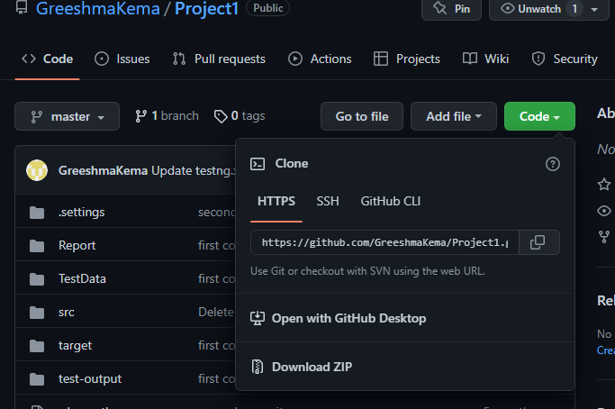

g

* Go to the file manager and select your desired location to download that project.
* Right click ->select gitbash here

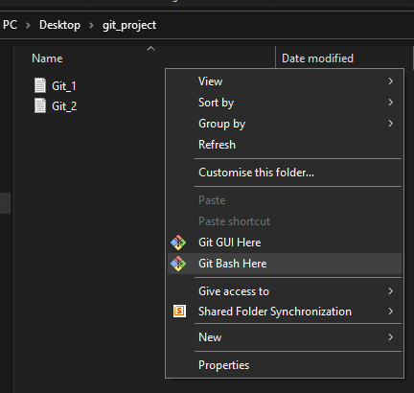

* Now Git Command line will open.
* Write git clone “URL”. (NOTE: Copy the “URL” from the repo)
* Press **Enter** to clone the repository. You’ll see a new file added to your local filesystem with your repository’s name. If you open this file, you’ll see it contains the files in your GitHub repository. These are copied versions of your repository’s files that you can edit and then push back to your repository.

